Product Manual

Name：Bluetooth LED Controller V1.0
Model：ZJ-BLV(A)-XY0

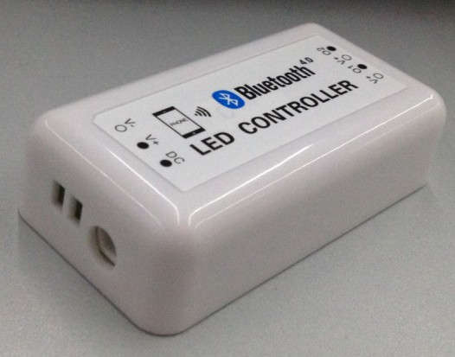

I. Product Summarize
This controller support Bluetooth version 4.0 or above.
It can achieve remote control ,switch light,adjust brightness and color temperature.There are 16 million colors and dozens of light changing modes.In addition.
This controller is designed for LED strip, module etc. After easy installation and settings, you can use your Phone (IOS or Android system) to control. The remote control distance reach 30 meters indoor and more than 60 meters outdoor.

II.Technical Parameter:
Conection Methods | Bluetooth Version 4.0
Suitable Phone OS | Any OS support Bluetooth version 4.0 or above
Software language | English
Channels | 310:4A/CH,2CH  320:4A/CH,Warm W :1CH,Cool W:1CH  370:4A/CH,R:1CH,G:1CH,B:1CH  410:Imax:0.7A/CH,Vmax:30V,3CH  420:Imax:0.7A/CH,Vmax:30V, Warm W:1CH,Cool W:1CH  470:Imax:0.7A/CH,Vmax:30V, R:1CH,G:1CH,B:1CH
Working Voltage | 310/320/370:DC12V-DC24V  410/420/470:Vmax:DC12-DC30V
Working Temperature | -20℃-60℃
Effective Romoted Distance | No barrier,60m ;Indoor, 30m
N.W | ≤61g
G.W | ≤101g
Waterproof | IP 25
Size | 86*45*23mm

*****************************************************************************************************************************
Warranty Time:

2 years(include scond year).Any problem caused by quality,we will provide free maintenance.

Remarks:

1.Pls don’t operate it when energized.
2.Pls don’t use it in areas which are full of metal and strong electromagnetic waves.Otherwise,effective remoted distance will be shortened significantly.

Notice:

1.Thanks for using our product .Pls read our product specification manual.When you use it ,it means that you have read our manual defaultly.
2.Our company have the right of exlanation and modification of all files equipped.Sorry for that we will not give you additional notice if there were many modifications.

